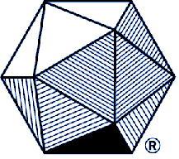

The Rocky Mountain Section of
The Mathematical Association of America

Voluntary Dues Contribution Form

Name | ____________________________________________________
Address | ____________________________________________________
 | ______________________________________ Zip___________

Please indicate in the space provided how you would like your dues to be used:

___________ | Undergraduate Student Initiatives
___________ | Graduate Student Initiatives
___________ | Distinguished Teaching Award Programs
___________ | Section Activity Grant Fund
___________ | Section NexT Program
___________ | Wherever needed most
___________ | Other: __________________________________________________
___________ | TOTAL DUES PAID ($10 recommended)

Please make check payable to: MAA Rocky Mountain Section

Return payment to the Section Secretary/Treasurer (for name and address, see the officers list at http://sections.maa.org/rockymt/2020_Officers.php)

