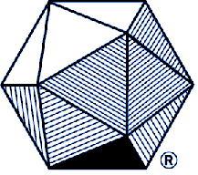 | The Rocky Mountain Section of  The Mathematical Association of America  2018 Burton W. Jones Award  for Distinguished College or University Teaching of Mathematics  Nomination Form | 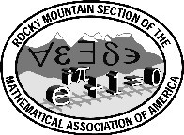

Name of Nominee
(First name first)

College or University Affiliation

College or University Address

City State Zip:

Is the nominee a member of the MAA?

Number of years of teaching experience in a mathematical science

Has the nominee taught at least half time in a mathematical science
for the past three years (not counting a sabbatical period)?

In the space below, please briefly describe the unusual personal and profession al qualities of the nominee that contribute to her or his extraordinary teaching success.

Name of Nominator
(first name first)

Address of Nominator

Email Address

Telephone: Work Home Fax

Nominator’s Signature

Nomination form should reach Section Awards Coordinator by 15 December 2017.
Complete nomination materials should reach Section Awards Coordinator by 15 January 2018.
Awards coordinator: Jeremy Muskat, Western State Colorado University, Hurst Hall, Gunnison, CO 81231
ehastert@jmuskat@western.edu

