In 1991 the Mathematical Association of America instituted Awards for Distinguished College or University Teaching of Mathematics in order to honor college or university teachers who have been widely recognized as extraordinarily successful, and whose teaching effectiveness has been shown to have had influence beyond their own institutions.

Citation

Dr. Stephen J. Greenfield

The New Jersey Section of the Mathematical Association of America is pleased to present its 2003 sectional award for Distinguished College or University Teaching of Mathematics to Dr. Stephen J. Greenfield.
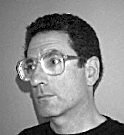
Dr. Greenfield is an inspired classroom teacher whose accomplishments go well beyond the classroom. He has served as mentor to many students by rehearsing job talks, advising students on job applications, helping graduate students teaching their own course for the first time, and discussing students' lives and mathematical careers. His activities also include course innovation leading to sustained change, successful applications for funding of educational activities, outreach to other programs, and educational administration. He has been meticulous about documenting his instructional activities on the web and his pages are considered regularly and extensively by people at Rutgers and elsewhere. All these activities have been of enormous help to the Rutgers Mathematics Department and have been greatly appreciated by his students.

Dr. Greenfield received his B.A. from Columbia University in 1963 and his M.A. and Ph.D. from Brandeis in 1965 and 1967, respectively. He was an Instructor at MIT from 1967 to 1969, and has been at Rutgers University since then. Dr. Greenfield has been vice-chair for both the undergraduate and graduate programs in the Rutgers Mathematics Department, has had long service on both the Department's graduate and undergraduate committees, and has served as the Department's head undergraduate adviser. Finally, he has been a Senior Science Teaching Fellow of the Rutgers Teaching Excellence Center.

Dr. Greenfield is a dynamic classroom presence. Students describe his lectures as crystal clear, entertaining, engaging, colorful, and filled with energy. He has taught an extremely wide variety of undergraduate and graduate courses, including twenty-four distinct courses on the undergraduate level and eleven on the graduate level. Whenever a course at Rutgers needs improvement, Dr. Greenfield either volunteers or is drafted to teach it. He has made major contributions to innovations in the teaching of mathematics and has played a key role in insuring that innovative efforts produced sustained change. Here are some examples: the establishment at Rutgers of the EXCEL program, our very successful program in calculus reform; the planning of the Introduction to Mathematical Reasoning course, designed to get students over the hurdle of learning to do mathematical proofs; the inclusion of graphing calculators and workshops in our calculus sequence for Mathematical and Physical Sciences; the selection and monitoring of our first large-scale use of peer mentors (undergraduates hired to work as teaching aides in calculus recitations); and the addition of a workshop component to the upper level courses in Advanced Calculus and Introduction to Abstract Algebra. For many of these workshops, materials he developed have been used (either verbatim or in adapted form) by virtually all subsequent instructors.

Dr. Greenfield was one of the Principal Investigators of the project
Smart Use of the Web to Enhance Learning in Math 135, part of the University Initiative in Innovative Instructional Technology. He was also one of five principal investigators for Rutgers' $200,000 award from the NSF for Institution-wide Reform of Science, Math, Engineering and Technology. Under this grant, Dr. Greenfield designed a course on the mathematics of communication to help liberal arts students work and participate in an increasingly technological society; here students not only learn about cryptography and its mathematical foundations, but also discuss and write about the public policy questions associated with this field. He also wrote two grant proposals which the U.S. Department of Education funded for a total of fifty-seven student-years of support for graduate students at Rutgers and wrote major portions of the proposal and served as one of five principal investigators for Rutgers' 2.5 million dollar award from the NSF VIGRE program.

The educational outreach activities of Dr. Greenfield have provided benefits to many students outside of Rutgers. He has given lectures to New Jersey high school students---some in their own schools, others at the Governor's Summer Academy, yet others in the summer young scholars programs run by DIMACS---and has advised high school students about opportunities at Rutgers. He also works extensively with high school teachers in New Jersey and across the country, and has served as project director at DIMACS summer institutes which promote interactions between high school teachers and mathematics researchers. Dr. Greenfield has served the U.S. government in educational initiatives as a reviewer for several U.S. Department of Education programs (e.g., the Minority Science Improvement Program and the Graduate Assistance in Areas of National Need program [GAANN]) and as a field assessor for the GAANN program.

Dr. Greenfield's teaching activities have previously been recognized by a number of awards. He received the Rutgers University Minority Advancement Program alumni award for encouraging minority graduate study in mathematics in 1994, the Faculty of Arts and Sciences Award for Distinguished Contribution to Undergraduate Education in 1996, and most recently, in 2000, the prestigious Rutgers University Warren L. Sussmann Award for Excellence in Teaching (awarded that year to only 4 of the over 3000 full-time faculty at Rutgers).

Dr. Greenfield's impact on the mathematics curriculum of undergraduates and graduate students at Rutgers and elsewhere has been immense, but his influence on individual students has been equally striking. One of his students wrote: ``I would not have become a math major nor would I have chosen to go into math education as a career if it were not for his guidance and inspiration. … Teachers like Dr. Greenfield come around once in a lifetime. I can never thank him enough.''

*******************************************************
Dr. Richard S. Falk of the Mathematics Department, Rutgers University-New Brunswick, nominated Dr. Greenfield for this Distinguished Teaching Award.

Response from Professor Greenfield

After winning the 1958 World Series, Casey Stengel said, "I couldn't have done it without my players."

Anyone who has stepped into a classroom or otherwise engaged a student knows that teaching and learning can't take place without the active participation of the students. So certainly I must thank my students first: they have been wonderful and irritating, and alert and asleep. They have made instruction of all kinds a fascinating and human activity.

The MAA was the first mathematics organization I joined, in my junior year of high school. Receiving an award from the MAA is therefore especially significant to me: in high school I understood a few articles in the Monthly, and felt that as I matured professionally more and more would be clear to me. Now, I still understand a few articles in the Monthly.
Teaching is only one part of being a faculty member at a major state university. It may even appear that teaching is not the most important activity there, but a large school has room for many types of excellence. I can honestly declare that Rutgers welcomes and values devotion to instruction.

I have been extremely fortunate in having very helpful colleagues, all excellent teachers themselves, who have been willing to bear with my enthusiasms and errors. Most notably, I cite Amy Cohen and Mike Beals at Rutgers, and Brenda Latka at Lafayette. Amy and Mike have endured years of my bursting into their offices, sometimes several times a day, with my latest explosion of irrelevance. Amy's energy, integrity, and deep devotion to all kinds to teaching is a constant source of inspiration. Mike has been stolen from the Math Department by the Dean's Office (along with another terrific colleague, Robert Wilson). Mike's ability to stay calm and focused on our educational aims has been invaluable. My friend Brenda has always asked me to see what students see, and try to adjust my aims and concerns from the students' point of view.

A large university has great inertia so changing courses and instructional methods can be difficult. For many years, Charlie Sims was in charge of our undergraduate program. His dedication and serious support have improved education at Rutgers in many ways. Our chair, Rick Falk, is truly concerned with teaching, and with providing the best kinds of instruction to all students. His quiet advice is remarkably wise.

I've had hundreds of conversations with colleagues from both colleges and high schools all over the country (many at the Advanced Placement calculus grading sessions). They have provided new ideas and varied points of view that have been marvelously stimulating and useful.

As my children, Sam and Larry, grew, and joined the crowd of students "out there", I more and more appreciated education as a joint enterprise. I certainly couldn't have done it without the students and that's been a great part of the fun.

RECIPIENTS OF MAA-NJ DISTINGUISHED

TEACHING AWARD

Sr. M. Stephanie Sloyan, Georgian Court College 1992

Eileen Polani, St. Peter’s College 1993

Richard Bronson, Fairleigh Dickinson University 1994

Siegfred Haenisch, The College of New Jersey 1995

Andrew Demetropoulos, Montclair State University 1996

Roger Pinkham, Stevens Institute of Technology 1997

Virginia Lee, Brookdale Community College 1998

Amy Cohen, Rutgers University-New Brunswick 1999

Janet H. Caldwell, Rowan University 2000

Evan Maletsky, Montclair State University 2002

Stephen J. Greenfield, Rutgers University-New Brunswick 2003

MEMBERS OF THE SELECTION COMMITTEE

Charles W. Herlands (Chairperson), The Richard Stockton College of NJ

Carlon Krantz, Kean University

Sandeep Maheshwari, William Paterson University

Daniel Gross, Seton Hall University

Janet Delaney, Passaic County Community College

MATHEMATICAL ASSOCIATION OF AMERICA

NEW JERSEY SECTION

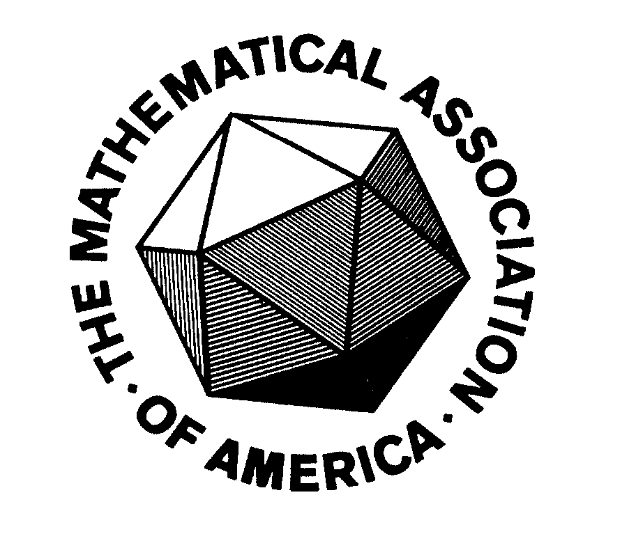

Award for Distinguished College or
University Teaching of Mathematics

Spring Meeting

Saturday, April 5, 2003
Kean University
Union, New Jersey

