47th Suncoast Regional Meeting of the Florida Section of the MAA
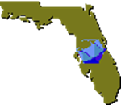 | 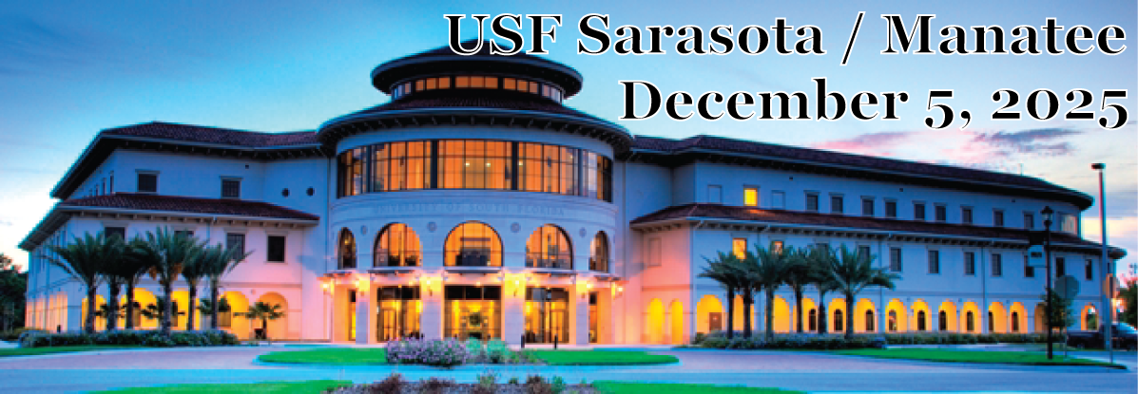 | 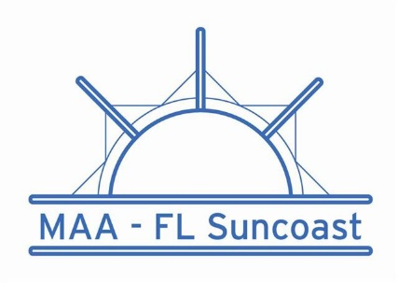
Pre-registration Form
First name Last name

Preferred name (for name badge)

Department Institution

Mailing Address

City State Zip Code

Email address

Pre-registration for students  (on-site registration is $ 10; free for student presenters) | $5
Pre-registration for everybody else  (on-site registration is $25) | $20
Evening Banquet (optional):  Fajita bar with flour & corn tortillas and rice, with meat, dairy, and vegetarian options. Also salad, fruit, dessert. | $25
TOTAL  (Payment by Zelle or by check) | $25 - $45

Payment by Zelle by November 21, 2025 to ivandecar@valenciacollege.edu  Please cc Pre-registration form to jdandrea@usf.edu  Payment by check: mail Pre-registration Form and check made out to Florida Section MAA so that it is received by November 21, 2025 to:  Suncoast Meeting  Joy D’Andrea  College of Arts & Sciences, B322  University of South Florida - Sarasota / Manatee  8350 N Tamiami Trl, Sarasota, FL 34243 | NOTE TO CONTRIBUTORS:  All proposals for contributions must be received (by email to mccolm@usf.edu) by November 21, 2025. Send title and abstract (as an MS Word attachment - as a doc, docx, or rtf file) to the Program Chair, Gregory McColm, at mccolm@usf.edu.

For more information about the MAA Florida Section, visit our website.

